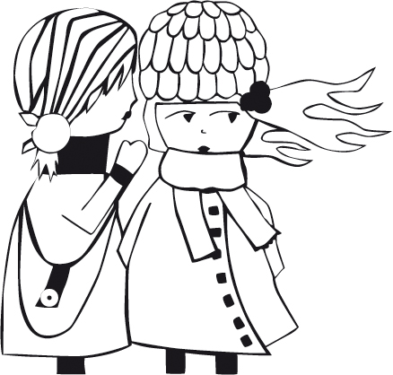
Lo que creas tú
What you believe

Dialogues list in english:

Lucía (off): Candela told me one day after the school. I didn’t quite believe it but she was convinced.

Candela: Ask them, let’s see what they tell you!

Julia: And, what do you think, Mr Babu? Candela lies, isn’t she?

Julia: And all that they had told me at school?

Paz: The important thing, Julia, is what you believe…and what do you believe? huh?

Julia (off): From that moment on, I would pay more attention. I wouldn’t believe everything they told me. Besides, I had a plan…

Pablo: It’s mine!

Rafa: Julia! , let your brother go right now.

Julia: I’m sorry dad, I hadn’t seen you.

Rafa: The one who is seeing you is the bird Pinzon. If he tells The Three Wise Kings….they are not going to bring you anything.

Rafa: and... who told her that?

Paz: Candela.

Rafa: But...Candela who? Campo or Casasnovas?

Rafa: How have they behaved yesterday?

Paz: Very well, they’ve behaved very well.

Paz: Campo. Her parents must have told her. It would have been yesterday after the school because I’ve seen them together.

Rafa: Do you think that she has believed it?

Lucía (off): The moment had come. I had to begin my plan. Until the sixth of January I would carry out two investigations. The first one was about to begin.

Rafa: Julia, we’ve told you a thousand times not to close the bathroom door! But… what’s taking you so long? What a nice week you are having, honey…!

Julia: I’m sorry Mr impatient, I’ve lost one tooth!

Rafa: It has finally fallen out, has it fallen out or have you pulled out yourself?

Julia: It has fallen out itself. I washed it and I’m going to put it under the pillow now.

Rafa: Come on!

Julia: Goodbye Mr Babu, don’t fall asleep!

Julia (off): This first evidence was key to my plan because I had obtained an immediate result and it had been a good trial for the final inquiry.

Paz: What are you doing here?

Julia: I’m putting water for the camels. And you?

Paz: Me...me… I got up to drink some water. But, come on! Hurry up and go to bed. If they find you here, they won’t leave you anything.

Pablo: One, two, three, four and...five. I’ve got five presents. And you? Julia.

Julia: I’ve got five presents too, Pablo.

Julia (off): That morning I understood that the shove the bird Pinzon gave Pablo had been overlooked. At night I understood that Candela was right.

Julia (off): So, first it was the bird Pinzon, then the Fairy Mouse and finally The Three Wise Kings.

Julia (off): And what I’m asking myself now is... what about you?

Julia (off): I suppose that the important thing is what you believe.

